**Launcher Instructions – Ping Pong Launcher**

**Mark Holdsworth – mjh357**

This project is designed to use the Mechatronics Toolchain for microprocessor programming.

**Electronics**

The drive electronics are:

* + STM32F446RE microcontroller
  + 3x DRV8835 Dual Motor Carrier Drivers
  + 2x N20 DC Motor 1:298 Dual shaft
  + 3x 6V HPCB 5:1 DC Motors

And associated accessories. Each DC motor is equipped with magnetic encoders to allow control over position from PWM signals. The circuitry is contained on a hand-soldered circuit board. This board has footprints for the STM32 microprocessor, the motor drivers and pinouts for each motor connection. It also features an inline fuse for component safety. Ensure the motors are connected in the correct location or they all won’t spin in the same direction.

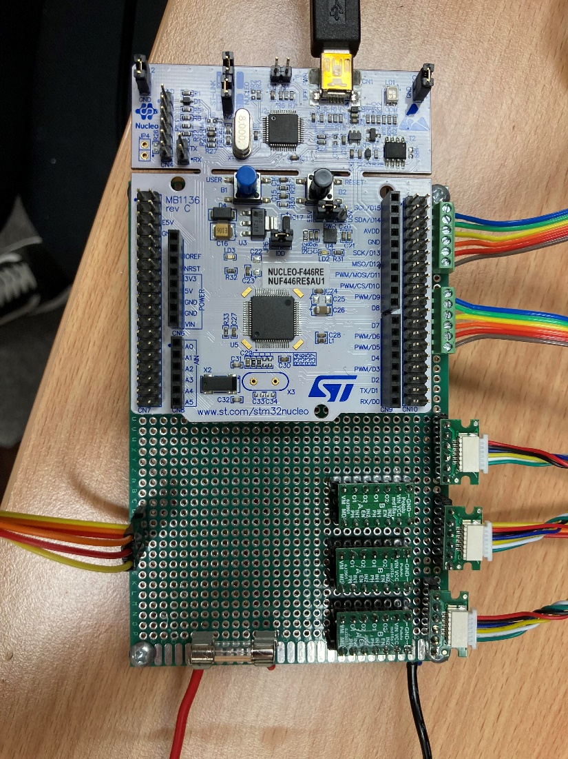

**Power Jumper**

**Motor Drivers**

**Servo**

**Fuse**

**Power In**

* **Elevation**
* **Azimuth**
* **Motor 1**
* **Motor 2**
* **Motor 3**

**Ground**

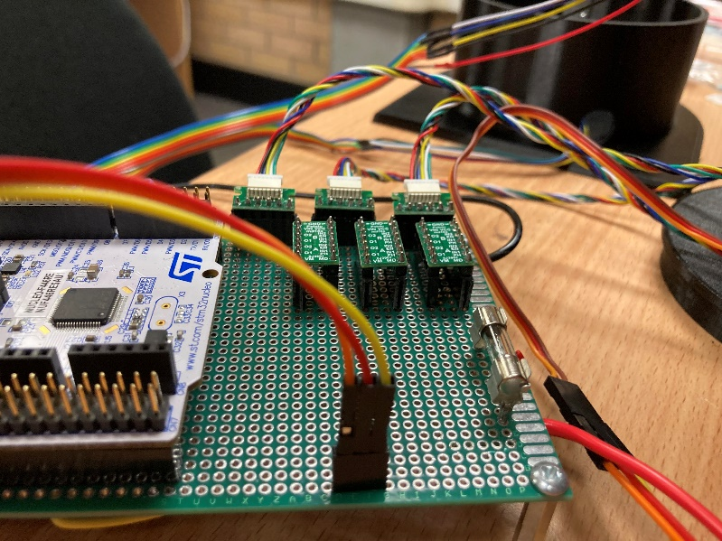

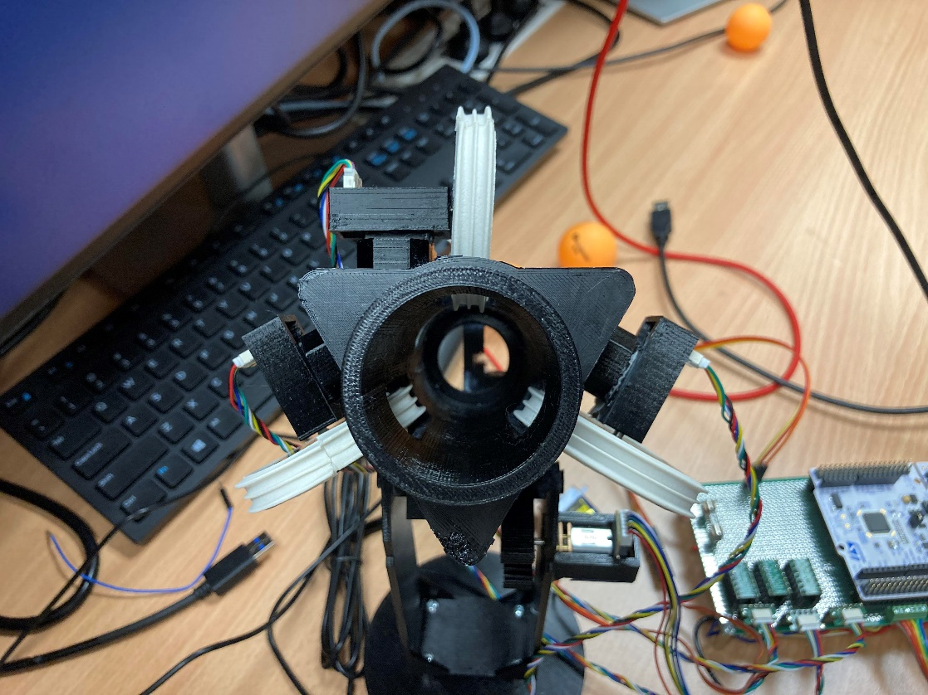

**MOTOR 2**

**MOTOR 3**

**MOTOR 1**

**Powering**

The circuitry is designed to be powered by an external 6V supply. This supply can be provided either by a battery or power supply. Estimated maximum current is around 5 amps, and an appropriate fuse should be used. The 6V power must be routed through the power and ground wires shown in the diagrams above. **IMPORTANT – the power jumper indicated must connect the External E5V pin and the centre pin.**

**Hardware**

The launcher is entirely 3D printed with PETG filament. The 3D models used are available on the GitHub for this project. Note that special plastic glue is required to join polyethylenes.

The launcher wheels use window sealing rubber strips around their circumference to grip the ping pong balls. The ends were superglued together to ensure they don’t come off during operation. Fishing line can also be tied in the valleys of the strips to keep the strips on.

The launcher stand is designed to be affixed to the base with serfaces flush, however due to the hex hut for the azimuth control, a hole must be drilled to ensure this. Stand offs are used to create a space as a temporary measure.

**User Interface**

The launcher can be controlled from the Coolterm application available in the MCHA toolchain. A serial port baudrate of 115200 must be selected, and the terminal must be set to ‘Line’ mode.

Launching is simple. The ‘help’ command provides a list of the commands available and what they do. Adjust the elevation until the launcher is horizontal and the azimuth until the barrel is centred. The calibration command will then zero the angular values. Set the desired azimuth and elevation angles in degrees.

To launch, set the velocity of the launcher motors to 2000RPM. Once steady, call the launch command to push a ball through the mechanism.

**Software**

Additional scripts can be made to increase functionality. It is importance that these scripts have both a .c and .h file within the src file, and that the scripts be added to the makefile script in the workspace. All software will be available through the GitHub.

**Next Steps**

For vision integration, it is recommended another microprocesser be used along with OpenCV to detect the red cups. The idea is that this vision system would provide cartesian coordinates from the launcher to the cup. Backsolving for the initial conditions of projectile flight is fairly simple. Serial communication can then be used to run the commands implemented in the launcher to aim and fire the projectile. This implementation can be achieved in several ways; the current state of the launcher attempted to keep this as open as possible.

For demonstration purposes, a big red button was purchased to act as the ‘fire’ button. It is recommended that this is implemented with an external interrupt one of the azimuth interrupt lines. When triggered, this should call the launch command that activates the servo to push a ping pong ball into the launcher mechanism.

The launcher itself is operational, however some improvements are nessesary. It is hard to combine the launcher to the base as the way the azimuth motor is fixed is tricky. It is recommended that a hole be made to allow access to the set screws within the hex nut from the outside. This will allow the launcher to be put together more easily to fit on the bearings properly without stressing the azimuth motor mount.

Additionally, the launcher motors need to be fixed more solidly. A clip over or even a cable tie would work. This is so the ball passing through the barrel doesn’t push the motors out of their housing and decrease launcher effectiveness.

The plunger rod needs to be reprinted or sanded down as it does not travel smoothly in the rack and pinion slot.